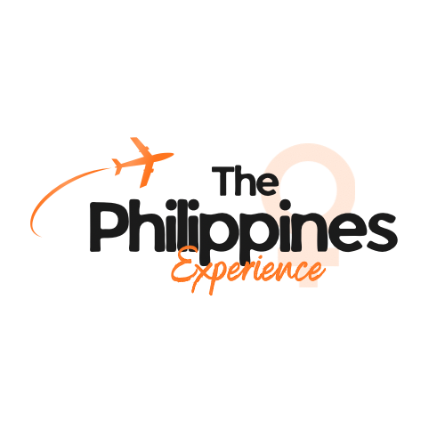

A-Sisterhood Philippines Experience 2026

Part of the “Give Back, Go Far Experiences”

Expression of Interest & Participant Agreement Form
This form expresses your interest in joining the A-Sisterhood Philippines Experience and outlines the expectations, conditions, and responsibilities associated with participation. Completion of this form does not guarantee selection. All selected participants must meet the criteria and agree to the conditions below.

Eligibility & Requirements
To be considered, applicants must:
- Fundraise/donate/arrange sponsorship of a minimum of £3,000 for A-Sisterhood by 30th June 2026. This must be paid directly to A-Sisterhood and not through any third party.
- Not be competing in any pageant system that is also supporting A-Sisterhood (as other arrangements apply in this case). If you are competing in a system that supports us, it doesn’t necessarily preclude you from the trip – there will just be other criteria. Please contact Paula if this is the case.
- The £3,000 you fundraise will be counted from deposits made to A-Sisterhood from the date of this agreement until 30 June 2026.

Conditions of Participation

The participant must:
- Identify as female and be aged 18 or older by the date of travel
- Hold a valid British passport (or equivalent that permits travel to the Philippines)
- Obtain a Philippine visa if required
- Be fit to travel, with no medical conditions that would prevent full participation
- Be available for the full duration of the approximately week-long trip (likely August)
- Travel exclusively with the A-Sisterhood party - no third parties may accompany

- Agree that the place on the tour is available to the participant only – and is not transferable
- Travel on the 2026 experience – deferrals are not permitted
- Agree to follow the itinerary and schedule as presented by A-Sisterhood
- Be responsible for her own travel insurance, transport to/from the UK airport, and incidental expenses
- Be responsible for obtaining any required vaccinations at her own cost
- Be professional and timely communication with the A-Sisterhood team
- Participate in pre-departure orientation briefings
- Share details of the experience on social media platforms as part of the campaign
A-Sisterhood Commitments:
- A-Sisterhood will prepare a full and engaging itinerary
- A-Sisterhood will arrange and cover the cost of flights, accommodation, and internal transport in the Philippines
- Please note however, A-Sisterhood is not liable for circumstances beyond its control (e.g., international law, natural disasters) that may affect the trip

I understand and will abide by the criteria above and formally sign to express my interest in The Philippines Experience 2026.

Participant Details
Full Name:
Address:
Email:
Phone Number:
Instagram handle:
Signature (The participant):
Date:

Signed on behalf of A-Sisterhood
Name: Paula Abbandonato
Signature:
Date:
Please return this completed form to:
📧 paula@a-sisterhood.org.uk
📞 T: 07903112663
🌐 www.a-sisterhood.org.uk

